**Robotic Operating systems and robot simulations**

Name : Girish S

Roll no: AM.EN.U4AIE22044

# **Labsheet 2**

1. Create a publisher node subscriber node to publishes consecutive integers on the topic counter at a rate of 2Hz and subscribe the count.

Code :   
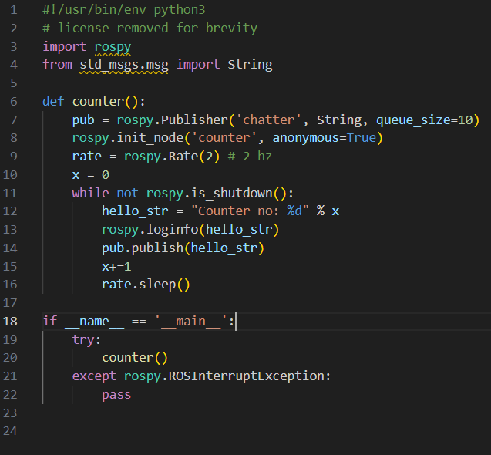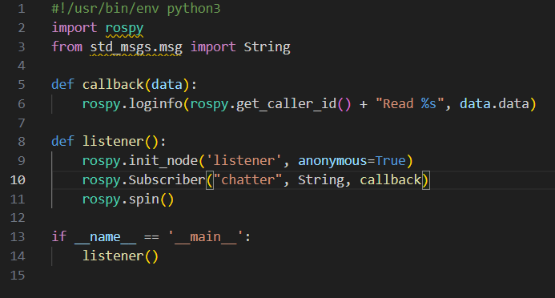

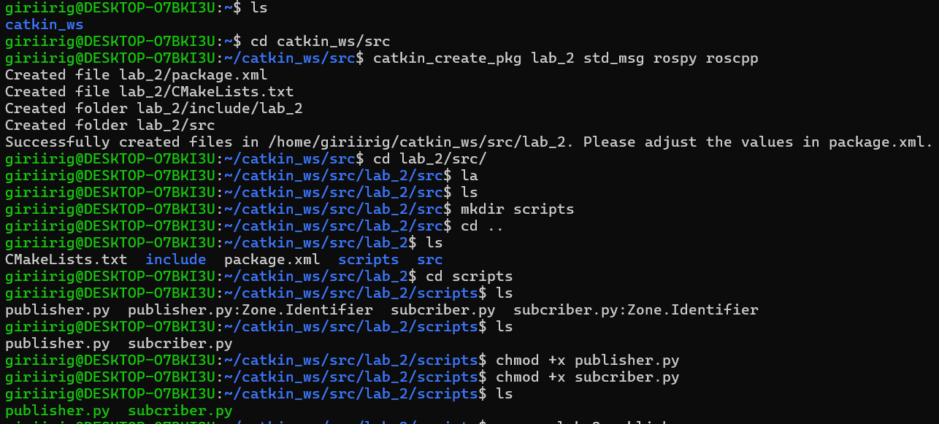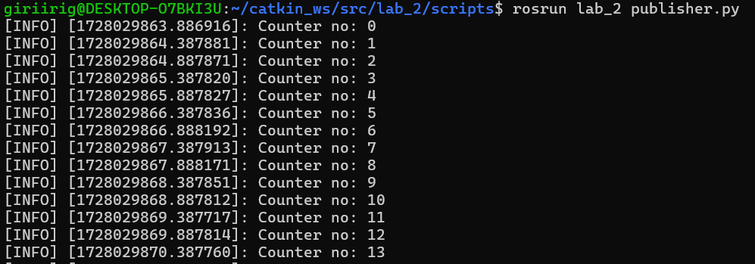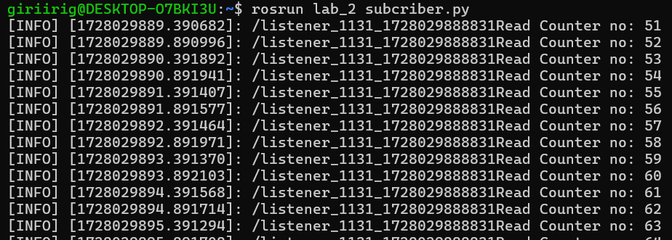

1. 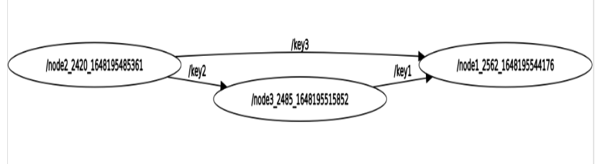Create a Communication System in ROS with multiple publisher and subscriber.

Key1-int Key2-float Key3-String

# Node 2

# Node 3

# Node 1

# Launcher.launch

# Output

# Output